Patient Payment Estimator (PPE) in eCare NEXT®

**Screen Changes**

When the User first accesses the Procedure Picker Page, they will be taken to a Start Page. This is basically the home page of the Pick List.

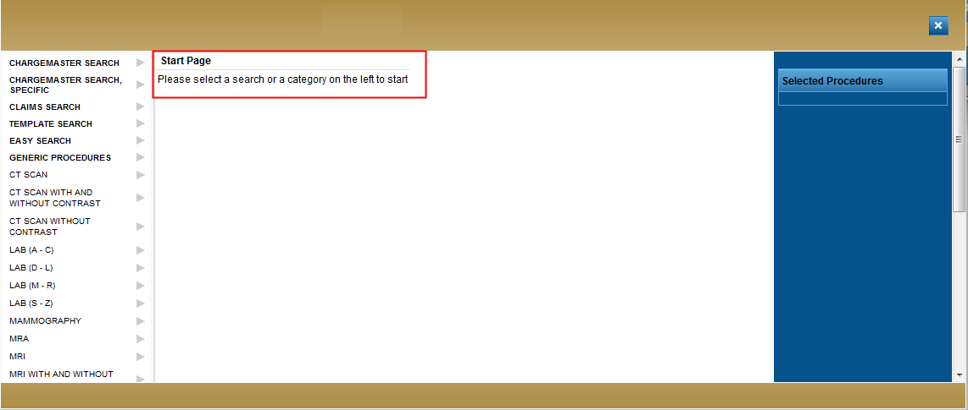

The User will then be directed to select either a Search tool or a Template category to proceed.

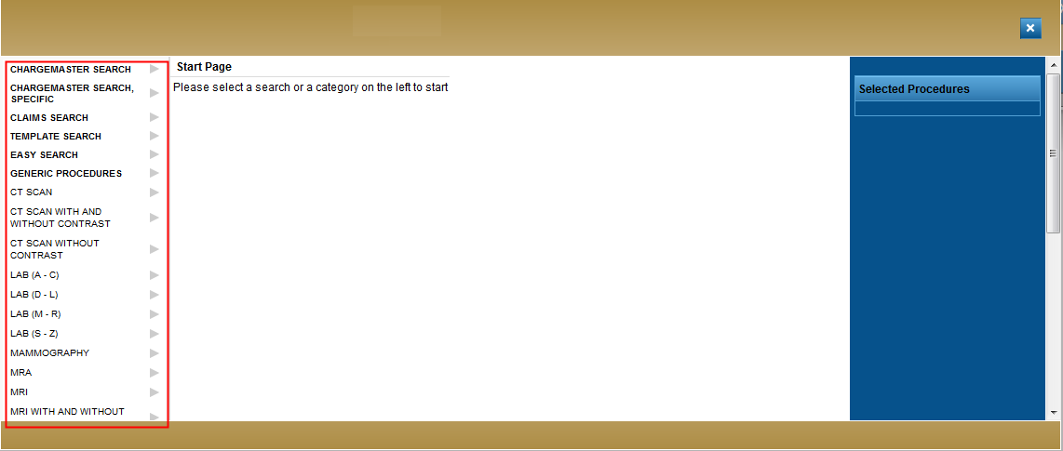

**Search Type Specific Changes**

**Chargemaster Search –**

When a User enters in either a code or a term and hits “Enter”, they will now see an indicator letting them know the search is in progress.

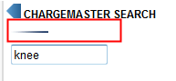

Once the search has completed, the results will display –

There will be either an “H” or a “P” next to each procedure. The “H” indicates this is considered a “Hospital” charge. The “P” indicates this is considered a “Professional” or “Physician” charge.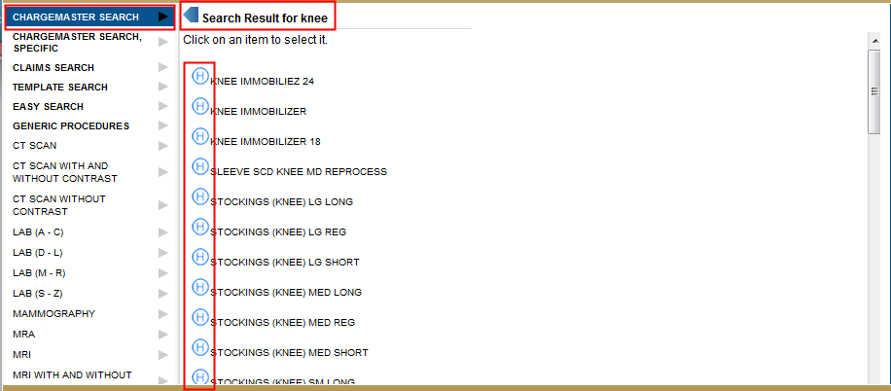

The User can select as many procedures as needed to run the estimate by simply clicking on the procedure name. This will move the selected procedure into the shopping cart.

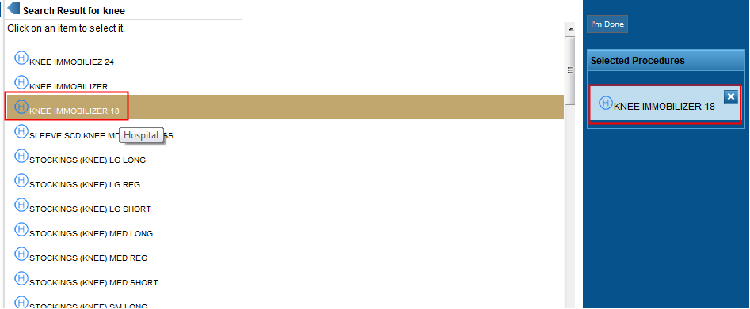

The User can return to the Chargemaster Search option by clicking on the Chargemaster Search again.

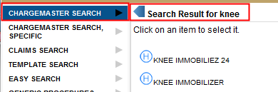

**Chargemaster Search, Specific –**

The User will see four options displayed here. They can only enter in one option per search.

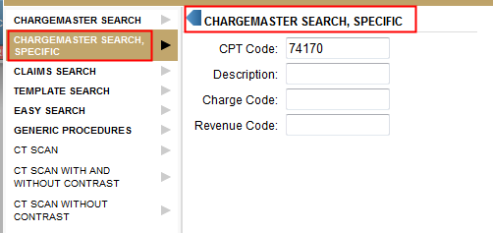

Once the User enters in a specific code or description and hits “Enter”, they will now see an indicator letting them know the search is in progress.



Once the search has completed, the results will display –

There will be either an “H” or a “P” next to each procedure. The “H” indicates this is considered a “Hospital” charge. The “P” indicates this is considered a “Professional” or “Physician” charge.

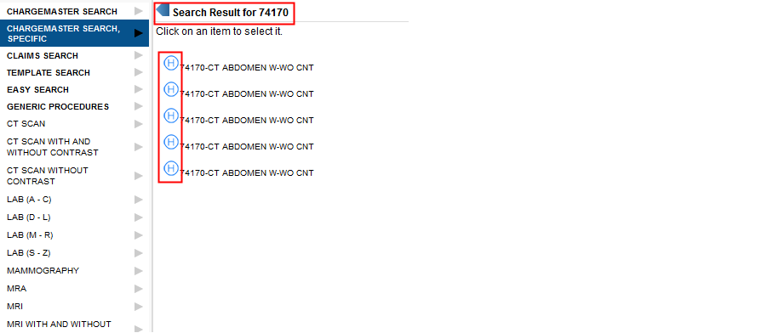

The User can select as many procedures as needed to run the estimate by simply clicking on the procedure name. This will move the selected procedure into the shopping cart. 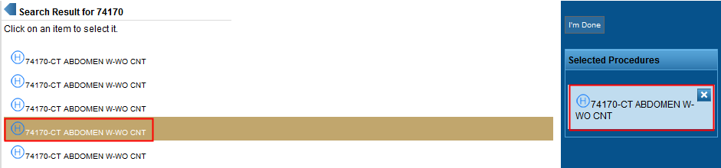

The User can return to the Chargemaster Search, Specific option by clicking on the Chargemaster Search, Specific again.

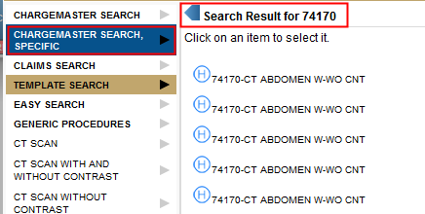

**Claims Search-**

The Outpatient Claims Search will function just as it did before. The User will enter in either the description, keyword or appropriate code and the matching results will display in a new page.

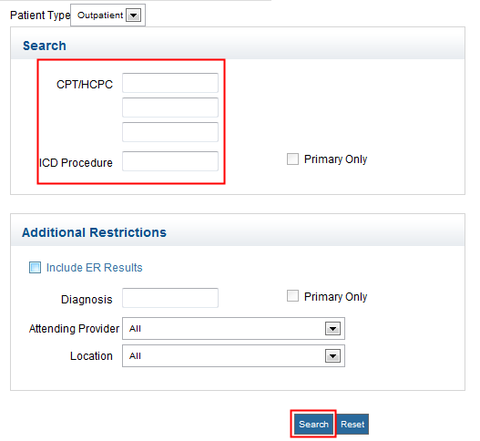

The User will select the apprpriate group of claims for the estimate

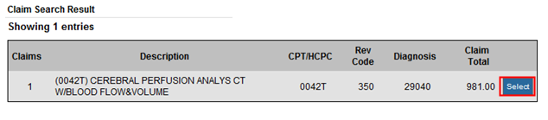

Once the User makes a selection, the screen will display all procedures and pricing associated with the selected group of claims.

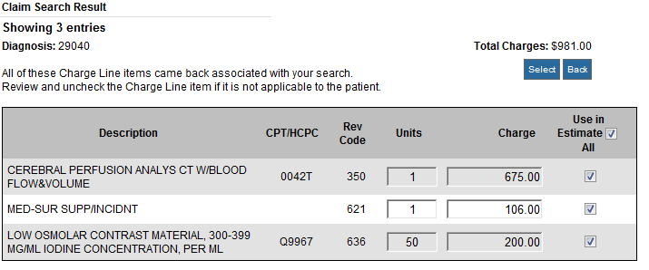

The InpatientClaims Search will function just as it did before. The User will enter in either the description, keyword or appropriate code and the matching results will display in a new page.

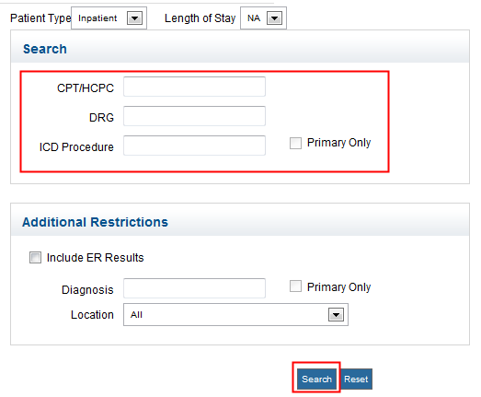

We have now added the Professional component of the Claims Search. This search functions much like the other Claims Search options, but feeds directly off of 837p claims.

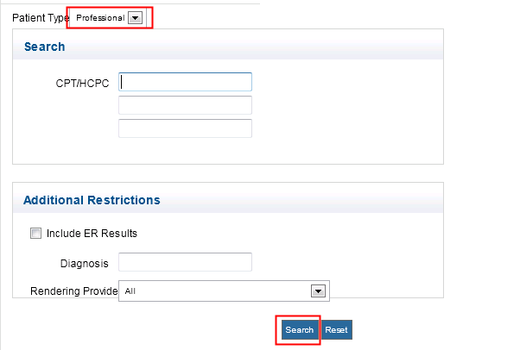

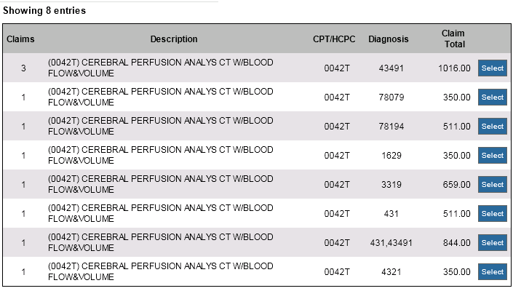

**Template Search-**

When a User enters in either a code or a term and hits “Enter”, they will now see an indicator letting them know the search is in progress.

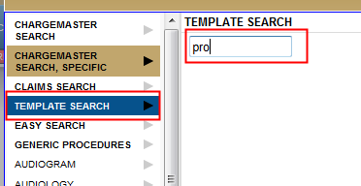

Once the search has completed, the results will display –

There will be either an “H” or a “P” next to each procedure. The “H” indicates this is considered a “Hospital” charge. The “P” indicates this is considered a “Professional” or “Physician” charge.

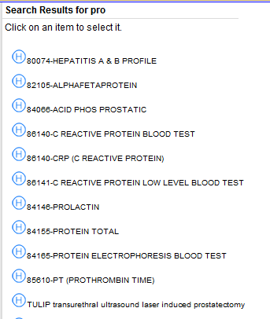

The User can select as many procedures as needed to run the estimate by simply clicking on the procedure name. This will move the selected procedure into the shopping cart.

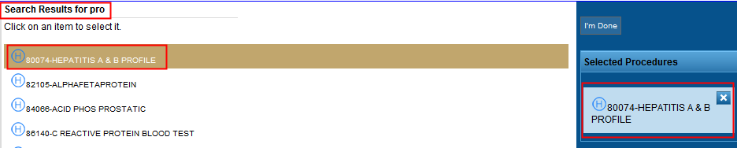

The User can return to the Template Search option by clicking on the Template Search again.

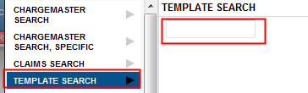

**Easy Search**

Easy Search functionality has changed slighly with this deployment.

Now the Easy Search columns are customizeable based on the User’s needs. When the user selects the Grid icon, a list of checkboxes appears. The User can determine which columns they would like to see appear in their Easy Search. The selection only needs to be made once, and will hold the selected columns each time the User returns to the search.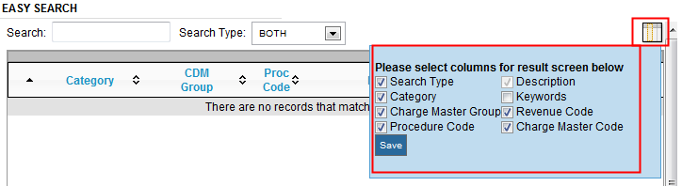

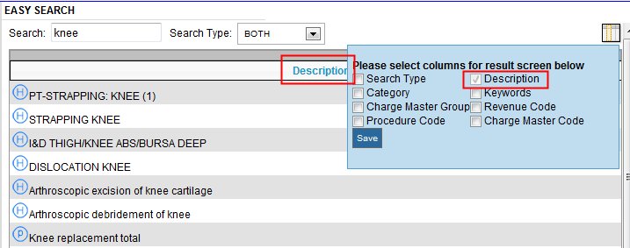

From here, the Easy Search will function just as it did before. The User will now also see “H” or “P” icons returned as well, which indicate whether this is considered a “Hospital” or “Professional” charge.

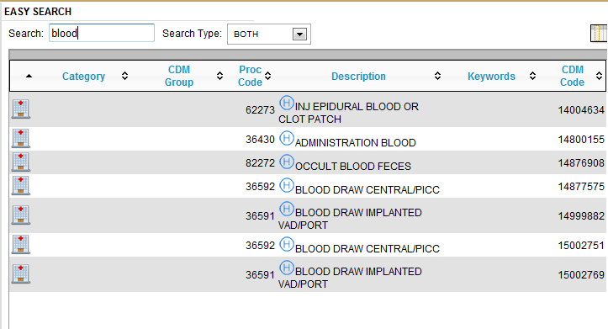

**Generic Procedures-**

There have been a few updates around Generic Procedures. The User is allowed to enter in a CPT code, which will assist in obtaining contractual rates.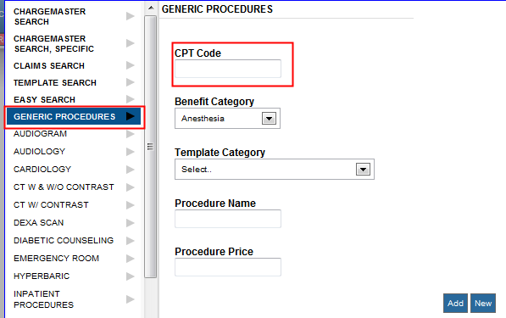

**Professional Selection from Template –**

The final major changes revolve around the Professional capabilities. If a selected procedure has a “P” indicator next to it, this indicates it is a Professional charge.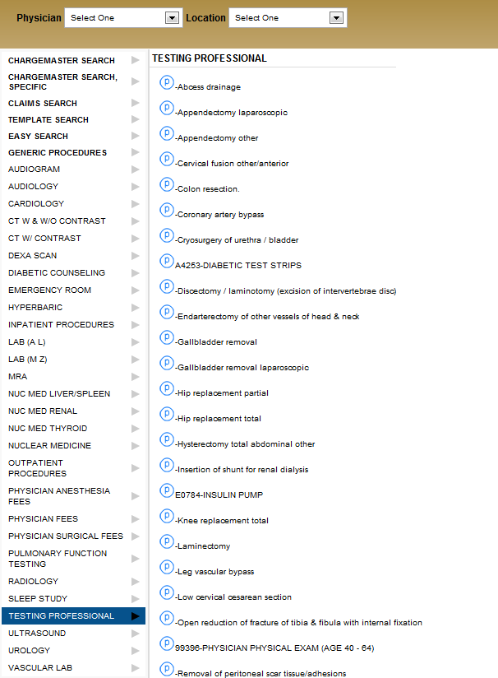

When a Professional charge is selected, 3 fields will appear. The User then has the option to provide further details that will provide more details for the contracting engine.

The User can now select from a list of Modifiers to attach to the selected procedure, add in a Type of Service or a Place of Service. 